**[Dotabase: a Dota 2 Database Visualizer](https://classes.soe.ucsc.edu/cmps161/Winter14/projects/athsueh/proj/projectReport.pdf)**

Francis Tang (fltang), Alan Hsueh (athsueh)

**Objective:** This paper provides an interface visualizing a different types of game data in new and unique way.

**Introduction**: On the day of 3/17/2014, there have been 663,760 concurrent players online playing Dota2, as taken from the game distribution platform, Steam. Clearly, a game with more than half a million players must have some sort of learning tool. There do exist many sites with guides to playing each of the many heroes in the game, as well as websites that keep track of player statistics. However, this paper’s goal of Dotabase is to devise something new and unique.

**Related Work:**

<http://dotabuff.com/> - from where you can query any player you want and see detailed results.

**Methods:**

1. A 3D scatter plot: displaying multiple heroes’ performance for a player.

2. A star plot: show the roles of a player, and their performance for each respective role.

3. A globe: this would show tournament win rate and matches of certain heroes.

Retrieved needed data with a MySQL/Apache server was set up in XAMPP to run PHP files from Dota Steam API. Fetched Data: *1. Match ID 2. Hero name 3. Kills 4. Deaths 5. Assists 6. Gold per minute 7. Experience per minute 8. Creep kills (last hits)*

***Results:***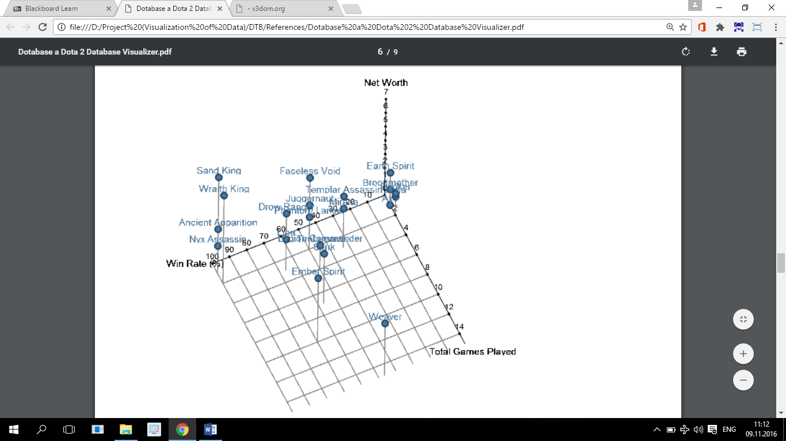

By the resulting graph generated by inputting data of the last 100 matches, many conclusions can be drawn. That being said, many heroes undergo balance changes every patch. So the win rate percentage and other rate percentages can significantly changes by the time pass.

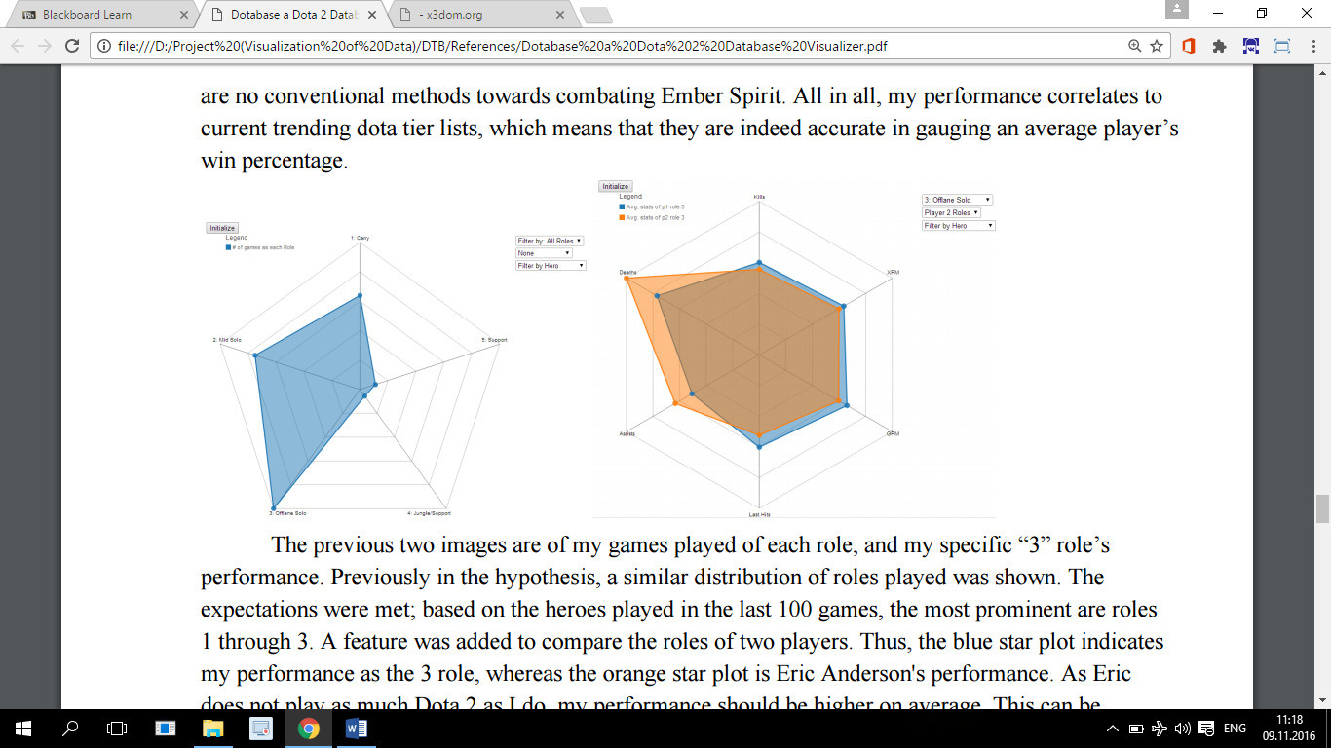

From this start plot, which helps players to compare with each other statistics, and also player can compare with himself in previous games played to see improvements.

**Conclusion/Relations to my project:**

This project provides a visualization of played games implemented with javascript (d3.js library). I was most interested in data fetching way in this paper, which I used for my project and this paper helped me to understand that statistics can be changed over time as heroes’ patches are changed.